**HSS roll configuration for each stand**

1. **Cutting production line:**

The finished product frame uses high-strength high-speed steel (HSS-Ⅱ), with a hardness of 82-88HSD, and the amount of steel passing exceeds 50%~100% of conventional high-speed steel (the better the working conditions, the more the amount of steel passing is increased). This type of roller is particularly suitable for strong water penetration processes such as British standard rebar. Because the rolling temperature is too low, the amount of steel passing of traditional high-speed steel rollers is low, the frequency of slot changing is high, and the labor intensity of workers is high; while tungsten carbide combination rollers are prone to cracks when rolling at low temperatures, the production cost is high, and the accident rate will also increase significantly.

The finished front frame uses conventional high-speed steel (HSS-Ⅰ) or high-strength high-speed steel (HSS-Ⅱ) with a hardness of 82-88HSD. The finished front frame uses rollers with higher materials, which not only increases the amount of steel passing, but also optimizes the material shape control, reduces the amount of pressure on the finished frame, and thus promotes a higher amount of steel passing on the finished frame.

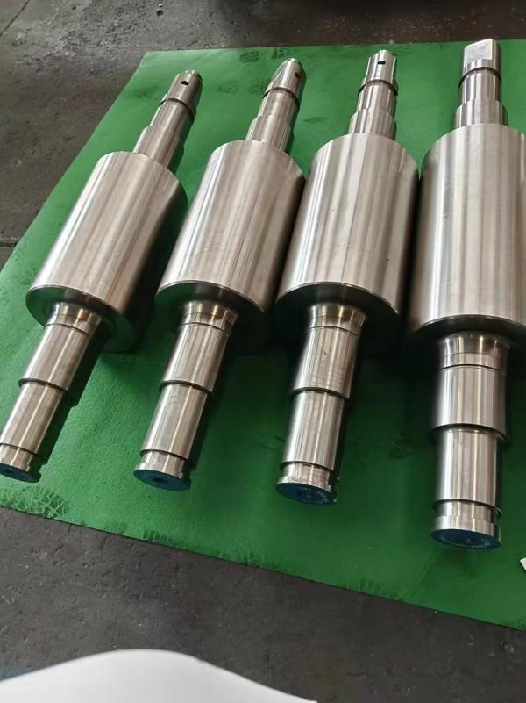

The cutting frame uses cutting high-speed steel (HSS-Ⅲ) with a hardness of 73-78HSD. The amount of steel passing is more than twice that of high-boron high-speed steel, and the impact toughness is higher than other materials, and it is not easy to fall off.

The pre-cutting frame uses conventional high-speed steel (HSS-Ⅳ) with a hardness of 78-83HSD. The amount of steel passing is more than twice that of high-boron high-speed steel, and the impact toughness is higher than other materials,and it is not easy to fall off. Block collapse groove.

1. **Single line, AB line, double line and other production lines:**

The finished product frame uses high-strength high-speed steel (HSS-Ⅱ), hardness 82-88HSD, and the steel passing rate exceeds 50%~100% of conventional high-speed steel (the better the working conditions, the more the steel passing rate is increased).

The finished product front frame uses conventional high-speed steel (HSS-Ⅰ) or high-strength high-speed steel (HSS-Ⅱ), hardness 82-88HSD, and the finished product front frame uses rollers of higher material, which not only increases the steel passing rate, but also optimizes the material shape control, reduces the pressure of the finished product frame, and thus promotes a higher steel passing rate of the finished product frame.

Other finishing and intermediate rolling mill frames use conventional high-speed steel (HSS-Ⅰ), and the steel passing rate is more than 3 times that of ordinary cast iron rollers.

**Other influencing factors**

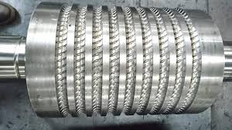1. The steel temperature must be uniform and free of impurities. For example, in a continuous casting and rolling production line, the temperature difference between the head and tail of the billet and the temperature difference between the inside and outside are large, exceeding 50°C, which has a greater impact on the wear of the rolls.

2. Optimization of rolling process, hole profile, material type, and the technical level of the adjuster, etc.